Requesting Access to KC Award Viewer

A user’s supervisor or representative is required to request access to the KC Award Viewer for the user.
Access can be requested at: https://iastate.service-now.com/it

Request Procedures:
- Start with the Login.

- Use the Search bar – search for: “kc award viewer”
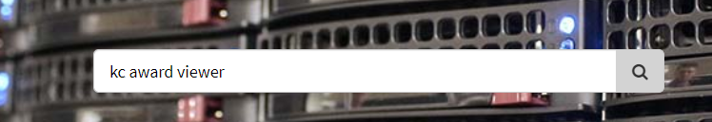

- Select Add/Remove Access to Sponsored Programs Administration
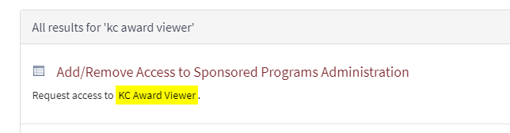

- Complete the Add/Remove Access to Sponsored Programs Administration form

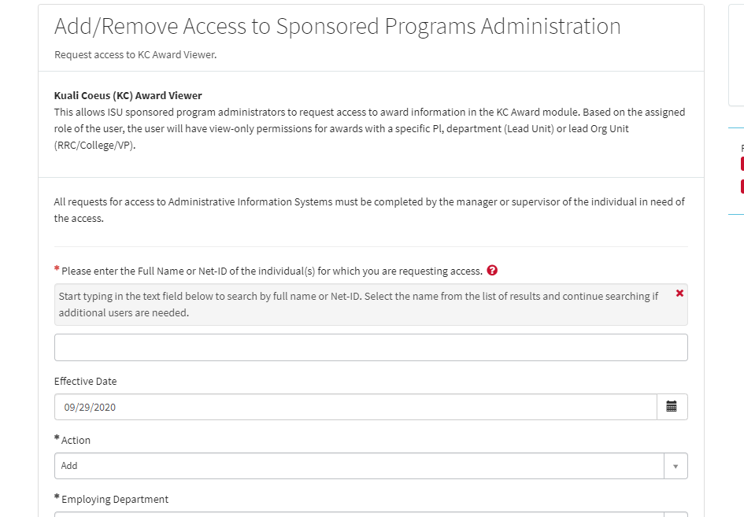
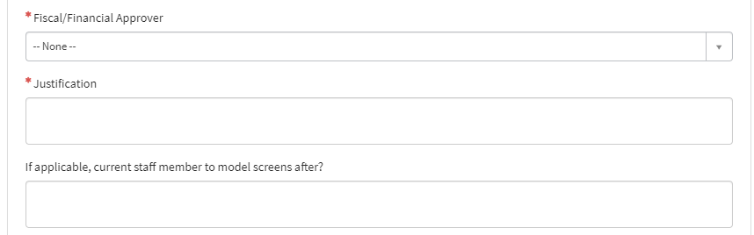

- Click Order Now in the top right of the page to submit your request.

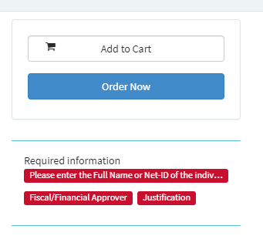
Note the required information for the request

